
COLLEGE CODE : 9605

COLLEGE NAME : CAPE INSTITUTE OF TECHNOLOGY

DEPARTMENT: CSE 3Rd YEAR

STUDENT NM- ID : BC9211705FC548288284149EDE9976E7

ROLL NO :960523104019

DATE : 24-10-2025

COMPLETED A PROJECT NAME AS PHASE -5

Technology Project Name : IBM – FE – E COMMERCE PRODUCT PAGE

SUBMITTED BY
NAME : ANANTHI S
MOBILE NUMBER:9087292136

Project demonstration and

Documentation

Final demo walkthrough:

- Purpose: Show how your project works from start to finish.

- Format: Can be a video recording, live demo, or slide walkthrough.

- Key Points to Cover:

  - Landing page and navigation
  - Product page layout (images, descriptions, price, ratings)
  - Add-to-cart / wishlist functionality (if implemented)
  - API integration (fetching product data)
  - Responsiveness on mobile & desktop
  - Any animations or interactive elements

Final report:

- Introduction:
  - Project title: IBM FE E-Commerce Product Page
  - Objective & scope of the project
  - HTML, CSS, JavaScript, React (if used)

Tech Stack :
- APIs (public/product API)
  - Any libraries (Bootstrap, Tailwind, Wiper’s, etc.)

- Features Implemented:

  - Product details display
  - Responsive design
  - Add to cart / quantity management
  - Reviews & ratings display (if any)

- Learning Outcomes:

  - Front-end development skills
  - API integration
  - UI/UX design principles

- Conclusion & Future Scope

Screenshot API / documentation:

- Screenshots:

  - Homepage
  - Product page
  - Cart / Checkout (if implemented)
  - Responsive views (mobile & desktop)

API documentation:

- Sample request & response

  - Integration method (fetch, axios, etc.)

Challenges and solutions

- Example:

  - Challenge: Product API was slow to respond
Solution: Implemented a loading spinner and error handling

  - Challenge: Responsive design breaking on mobile
Solution: Used CSS media queries & flexbox adjustments
  - Challenge: Cart functionality with dynamic data
Solution: Stored cart in localStorage and updated state dynamically

- Screenshot API / documentation:

<!DOCTYPE html>
<html Lang=”en”>

<head>
<meta charset=”UTF-8” />
<meta name=”viewport” content=”width=device-width, initial-scale=1.0” />
<title>E-commerce Website</title>
<link href=https://cdn.jsdelivr.net/npm/bootstrap@5.0.0-beta3/dist/css/bootstrap.min.css
<link href=https://cdn.jsdelivr.net/npm/tailwindcss@2.2.19/dist/tailwind.min.css rel=”stylesheet” />
<link rel=”stylesheet”
Href=https://fonts.googleapis.com/css2?family=Material+Symbols+Outlined:opsz,wght,FILL,GRAD@24,400,0,0 />
<link
Href=https://fonts.googleapis.com/css2?family=Poppins:wght@300;400;600;700&family=Roboto:wght@300;400;700&display=swap
Rel=”stylesheet” />
<style>
Body {
Font-family: ‘Poppins’, sans-serif;
Background-color: #f5f5f5;
}

Header {
Background-color: #fff;
Box-shadow: 0 2px 4px rgba(0, 0, 0, 0.1);
Padding: 1rem;
Position: sticky;
Top: 0;
z-index: 999;
}

Nava a {
Color: #6b46c1;
Font-weight: 600;
Text-decoration: none;
Transition: color 0.3s ease;
}

Nava a:hover {
Color: #805ad5;
}

.hero {
Background-image: linear-gradient(to right, #6b46c1, #805ad5);
Color: #fff;
Padding: 4rem 2rem;
Text-align: center;
}

.hero h1 {
Font-size: 3rem;
Font-weight: 700;
Margin-bottom: 1rem;
}

.hero p {
Font-size: 1.25rem;
Margin-bottom: 2rem;
}

.btn-primary {
Background-color: #6b46c1;
Border-color: #6b46c1;
Font-weight: 600;
Transition: background-color 0.3s ease, border-color 0.3s ease;
}

.btn-primary:hover {
Background-color: #805ad5;
Border-color: #805ad5;
}

.categories, .featured-products {
Padding: 4rem 2rem;
}

.categories h2, .featured-products h2 {
Font-size: 2rem;
Font-weight: 700;
Margin-bottom: 2rem;
}

.category-item, .product-item {
Background-color: #fff;
Border-radius: 0.5rem;
Box-shadow: 0 4px 6px rgba(0, 0, 0, 0.1);
Padding: 2rem;
Text-align: center;
Transition: transform 0.3s ease;
}

.category-item:hover, .product-item:hover {
Transform: translateY(-0.5rem);
}

.category-item img, .product-item img {
Object-fit: contain;
Margin-bottom: 1rem;
}

.category-item img {
Height: 100px;
Width: 100px;
}

.product-item img {
Height: 200px;
Width: 100%;
}

.category-item h3, .product-item h3 {
Font-size: 1.25rem;
Font-weight: 600;
Margin-bottom: 0.5rem;
}

.category-item p, .product-item p {
Color: #718096;
Font-size: 0.875rem;
}

.product-item .price {
Font-size: 1.25rem;
Font-weight: 600;
Color: #6b46c1;
}

.product-item div p {
Font-weight: bolder;
Text-align: left;
Margin-bottom: 0rem;
Color: #4F6F52;
}

Footer {
Background-color: #6b46c1;
Color: #fff;
Padding: 2rem;
Text-align: center;
}

.slider-container {
Display: flex;
Justify-content: space-between;
Border-radius: 0.5rem;
Box-shadow: 0 4px 6px rgba(0, 0, 0, 0.1);
}

.slider-container img {
Width: 50%;
}

@media (max-width: 768px) {
.slider-container {
Flex-direction: column;
}

.slider-container img {
Width: 100%;
}

Nav {
Flex-direction: column;
Align-items: flex-start;
}

Nav a {
Margin-bottom: 0.5rem;
}
}
</style>
</head>

<body>
<header>
<nav class=”flex justify-between items-center flex-wrap”>
<a href=”#” class=”flex items-center space-x-2 mb-2 md:mb-0”>
<h3 class=”text-lg font-bold text-purple-800”>E-Commerce Website</h3>
</a>
<ul class=”flex space-x-4 text-purple-800 font-semibold flex-wrap”>
<li><a href=”/FAQ”>FAQ?</a></li>
<li><a href=”/myOrders”>Your orders</a></li>
<li><a href=”/cart_item” id=”cartLink”>My Cart</a></li>
<li><a href=”/logout”>Logout</a></li>
</ul>
</nav>
</header>

<section class=”slider-container”>
<img loading=”lazy”
Src=https://media.geeksforgeeks.org/wp-content/uploads/20250724181649377442/ecommerce-cart.webp
Alt=”Slider 1”>
<img loading=”lazy” src=https://media.geeksforgeeks.org/wp-content/uploads/20250724124044580202/kids_1.jpg
Alt=”Slider 2”>
</section>

<section class=”hero”>
<h1>Welcome to our E-commerce Website</h1>
<p>Discover the best products and enjoy a seamless shopping experience.</p>
<button class=”btn btn-primary”>Shop Now</button>
</section>

<section class=”categories”>
<h2>Shop by Category</h2>
<div class=”grid grid-cols-1 sm:grid-cols-2 md:grid-cols-3 gap-4”>
<a href=”/men” class=”category-item”>
<img loading=”lazy”
Src=https://media.geeksforgeeks.org/wp-content/uploads/20250724124356374694/male_1.jpg
Alt=”Men’s Category”>
<h3>Men’s Wear</h3>
<p>Explore our wide range of men’s fashion.</p>
</a>
<a href=”/women” class=”category-item”>
<img loading=”lazy”
Src=https://media.geeksforgeeks.org/wp-content/uploads/20250724125020503946/women_5.jpg
Alt=”Women’s Category”>
<h3>Women’s Wear</h3>
<p>Discover the latest women’s fashion trends.</p>
</a>
<a href=”/kids” class=”category-item”>
<img loading=”lazy”
Src=https://media.geeksforgeeks.org/wp-content/uploads/20250724125020976003/kids_2.jpg
Alt=”Kids Category”>
<h3>Kids Wear</h3>
<p>Find stylish and comfortable options for your little ones.</p>
</a>
</div>
</section>

<section class=”featured-products”>
<h2>Featured Products</h2>
<div class=”grid grid-cols-1 sm:grid-cols-2 lg:grid-cols-3 gap-4”>
<!—Example Product
<div class=”product-item” id=”Product_1”>
<img loading=”lazy”
Src=https://media.geeksforgeeks.org/wp-content/uploads/20250724124201503672/women_1.jpg
Alt=”Product 1”>
<h3>Product 1</h3>
<p>Description: Dress 1</p>
<div>
<p class=”Discount”>Get 15% off</p>
<div class=”flex justify-between items-center”>
<span class=”price”>$200</span>
<button class=”btn btn-primary add-to-cart-btn”>Add to Cart</button>
</div>
</div>
</div>
<!—Repeat Products (Product_2 to Product_6)... same structure as above
</div>
</section>

<footer>
<p>&copy; 2024 E-commerce Website. All rights reserved.</p>
</footer>

<!—JavaScript
<script>
Let cart = JSON.parse(localStorage.getItem(‘cart’)) || [];

Document.querySelectorAll(‘.add-to-cart-btn’).forEach((btn) => {
Btn.addEventListener(‘click’, () => {
Const productCard = btn.closest(‘.product-item’);
Const product = productCard.id;
Const productName = productCard.querySelector(‘h3’).innerText;
Const productPrice = productCard.querySelector(‘.price’).innerText;
Const productImage = productCard.querySelector(‘img’).src;

Const product = {
Id: productId,
Name: productName,
Price: productPrice,
Image: productImage
};

Const exists = cart.find(item => item.id === product.id);
If (!exists) {
Cart.push(product);
localStorage.setItem(‘cart’, JSON.stringify(cart));
alert(`${product. Name} added to cart!`);
updateCartCount();
} else {
Alert(`${product.name} is already in your cart.`);
}
});
});

Function updateCartCount() {
Const cartCount = cart.length;
Let cartLink = Document.querySelectorAll(‘#cartLink’);
If (cartLink) {
cartLink. InnerText = `My Cart (${cartCount})`;
}
}

updateCartCount();
</script>
</body>

</html>

OUTPUT :

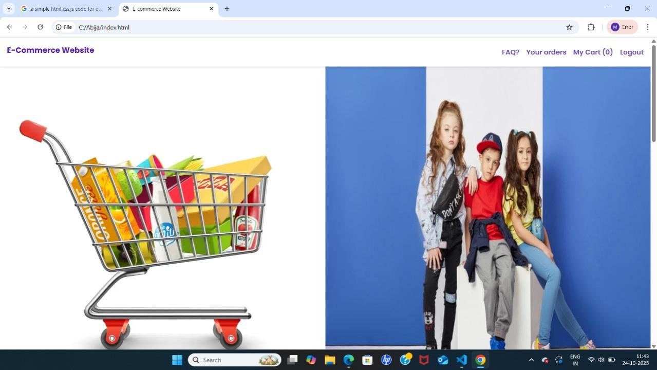
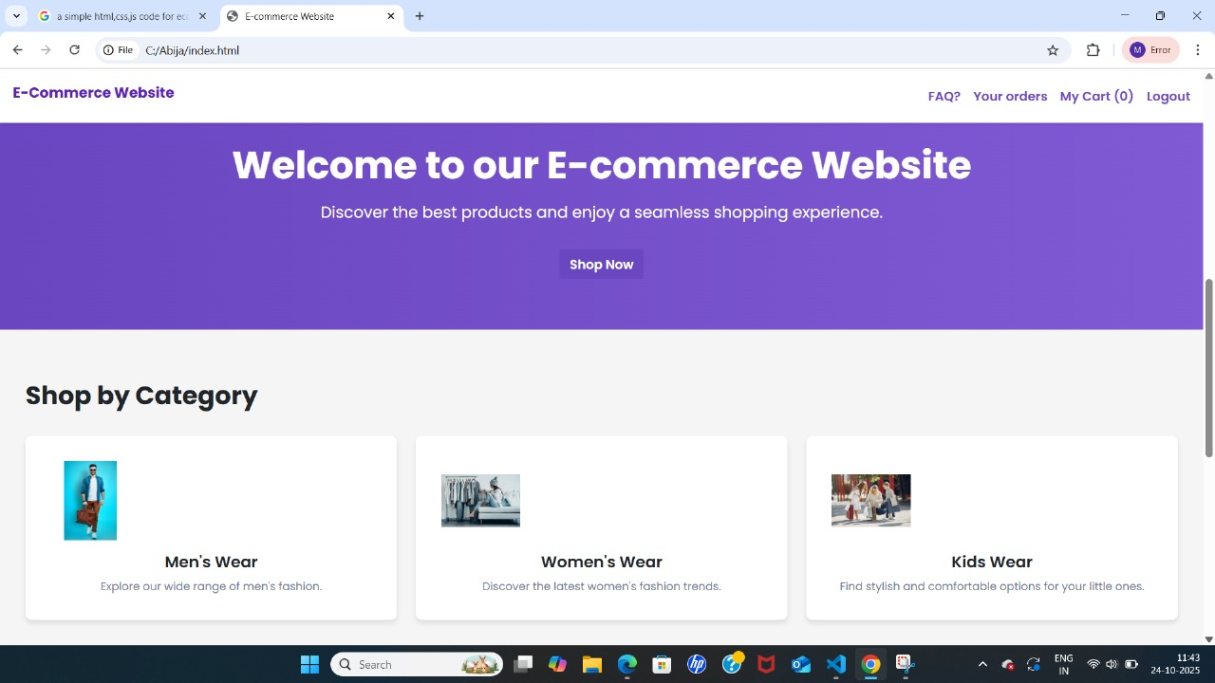
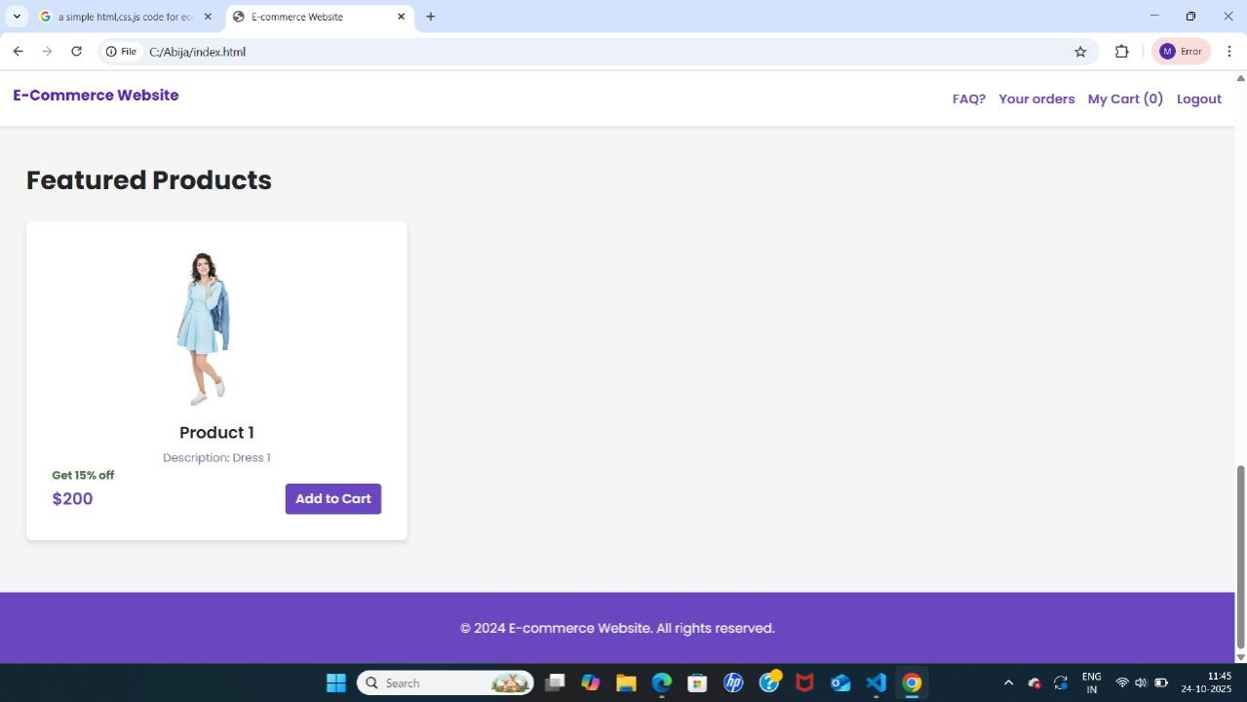

Challenge 1: API Data Fetching Issues

Problem:

Slow API response times caused delays in displaying product data.

Sometimes API returned errors or incomplete data.

Solution:

Implemented a loading spinner to indicate data fetching.

Added error handling to display a friendly message if API fails.

Used synch /await with try-catch blocks for better control of API calls.

Challenge 2: Responsive Design Problems

Problem:

Product page layout broke on mobile or tablet devices.

Images and text overlapped or overflowed the container.

Solution:

Used CSS Flexbox and Grid for layout structure.

Added media queries for different screen widths (mobile, tablet, desktop).

Tested extensively on multiple devices and emulators to ensure proper responsiveness.

Challenge 3: Cart Functionality

Problem:

Managing cart state across pages was tricky.

Adding/removing items dynamically caused UI to freeze.

Solution:

Used React state and localStorage to persist cart data across sessions.

Implemented functions to add, remove, and update quantities efficiently.

Used conditional rendering to instantly update UI after cart changes.

Challenge 4: Image & Media Loading

Problem:

High-resolution product images caused slow loading.

Page felt heavy and unresponsive.

Solution:

Implemented lazy loading for images.

Optimized images by compressing without losing quality.

Used placeholder images while actual images loaded.

Challenge 5: UI/UX Design Consistency

Problem:

Different components had inconsistent spacing, fonts, and buttons.

Some elements looked misaligned or cluttered.

Solution:

Created a style guide for fonts, colors, and buttons.

Used CSS variables for consistent theming.

Regularly reviewed the design and aligned components using Flexbox/Grid.

Challenge 6: Navigation & Routing

Problem:

Navigating between pages (Home → Product → Cart) sometimes caused state loss.

Hard to maintain smooth transitions.

Solution:

Used React Router for smooth page navigation.

Preserved cart state using context API or localStorage.

Added back/forward navigation support for better UX.

Challenge 7: Testing & Debugging

Problem:

Bugs appeared intermittently, especially with dynamic data from APIs.

Hard to identify why certain features failed on specific devices.

Solution:

Used browser developer tools and console logging for debugging.

Conducted cross-browser testing on Chrome, Firefox, Edge, and mobile browsers.

Added unit testing for key functions (optional but useful).

GitHub Repository:

https://github.com/ananthiselvaraj37/Commerce-.product-page-.git

